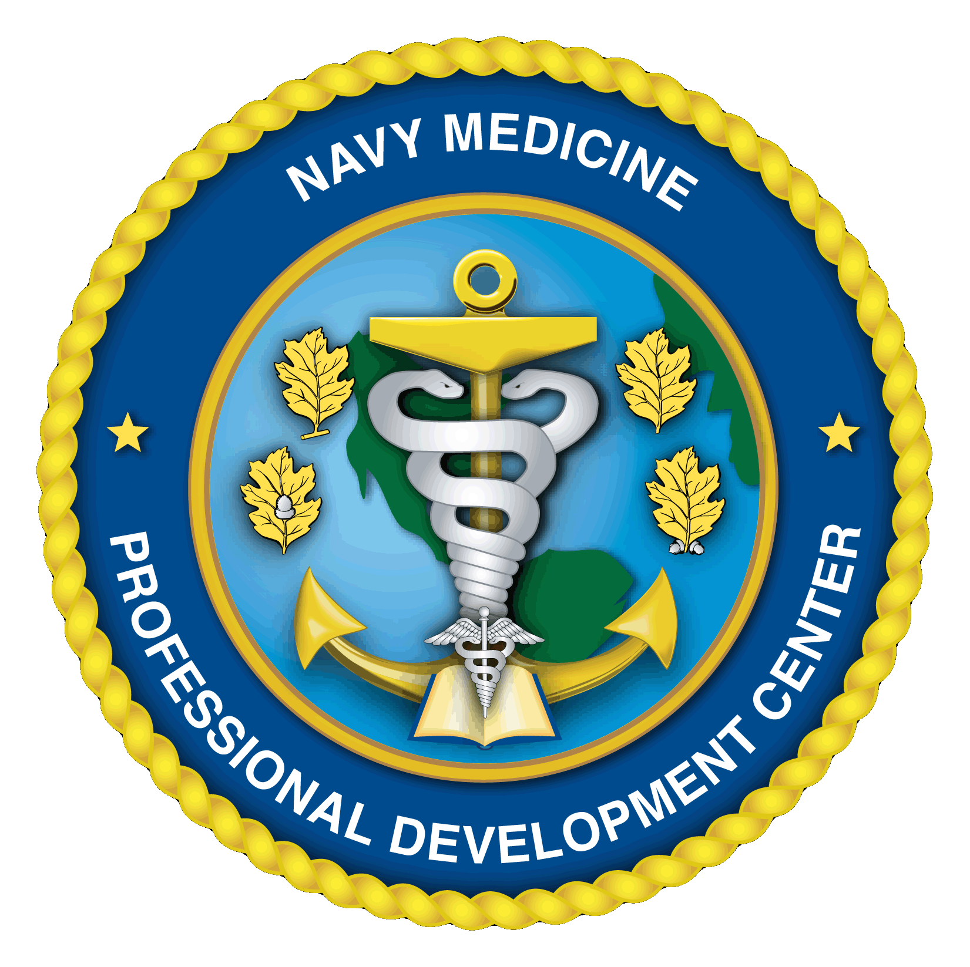 NAVY MEDICINE
PROFESSIONAL DEVELOPMENT CENTER
COURSE INFORMATION
Quick Reference – FY21 Course Dates – 3rd Ed.
As of 19 JUN 2020
Advanced Medical Department Officers Course (AMDOC)
Course Title | Course Number | Course Start Date | Course End Date |  | Nom Due Date
A-ROC | 21-10 | 19-Oct-20 | 30-Oct-20 |  | 07-Sep-20
A-ROC | 21-20 | 11-Jan-21 | 22-Jan-21 |  | 02-Dec-20
A-ROC | 21-30 | 15-Feb-21 | 26-Feb-21 |  | 28-Dec-20
A-ROC | 21-40 | 15-Mar-21 | 26-Mar-21 |  | 25-Jan-21
A-ROC | 21-50 | 19-Apr-21 | 30-Apr-21 |  | 01Mar-21
A-ROC | 21-60 | 14-Jun-21 | 25-Jun-21 |  | 26-Apr-21
A-ROC | 21-70 | 19-Jul-21 | 30-Jul-21 |  | 31-May-21
A-ROC | 21-80 | 16-Aug-21 | 27-Aug-21 |  | 28-Jun-21
A-ROC | 21-90 | 13-Sep-21 | 24-Sep-21 |  | 02-Aug-21
Clinic Management Course (CMC)
Course Title | Course Number/Location | Course Start Date | Course End Date |  | Nom Due Date
CLINIC MGMT | 21-10 / NHC NEW ENGLAND | 17-Nov-20 | 20-Nov-20 |  | 14-Sep-20
CLINIC MGMT | 21-20 / NH BREMERTON | 15-Dec-20 | 18-Dec-20 |  | 16-Oct-20
CLINIC MGMT | 21-30 / NMC LEJEUNE | 12-Jan-21 | 15-Jan-21 |  | 16-Nov-20
CLINIC MGMT | 21-40 / NH GUAM | 09-Feb-21 | 12-Feb-21 |  | 14-Dec-20
CLINIC MGMT | 21-50 / NMC PORTSMOUTH | 16-Mar-21 | 19-Mar-21 |  | 11-Jan-21
CLINIC MGMT | 21-60 / USNH YOKOSUKA | 13-Apr-21 | 16-Apr-21 |  | 15-Feb-21
CLINIC MGMT | 21-70 / NMC SAN DIEGO | 11-May-21 | 14-May-21 |  | 12-Mar-21
CLINIC MGMT | 21-80 / BETHESDA MID -ATLANTIC CLINICS | 15-Jun-21 | 18-Jun-21 |  | 09-Apr-21
CLINIC MGMT | 21-90 / USNH NAPLES | 13-Jul-21 | 16-Jul-21 |  | 14-May-21
CLINIC MGMT | 21-100 / NH CAMP PENDLETON | 10-Aug-21 | 13-Aug-21 |  | 11-Jun-21
CLINIC MGMT | Faculty Conference (Bethesda) | 31-Aug-21 | 03-Sep-21 |  | N/A
Financial & Materiel Management Training Course (FMMTC)
Course Title | Course Number | Course Start Date | Course End Date |  | Nom Due Date
FMMTC | 21-10 | 12-Oct-20 | 19-Nov-20 |  | 01-Sep-20
FMMTC | 21-20 | 22-Feb-21 | 06-May-21 |  | 16-Dec-20
FMMTC | 21-30 | 12-Jul-21 | 23-Sep-21 |  | 11-May-21
Military Tropical Medicine (MTM)
Course Title | Course Number | Course Start Date |  | Course End Date | Nom Due Date
MTM-DIDACTIC | 21-10 | 05-Jul-21 |  | 30-Jul-21 | 01-Mar-21
MTM-FIELD | 21-20 | 30-Jul-21 |  | 13-Aug-21 | 01-Mar-21
NAVY MEDICINE
PROFESSIONAL DEVELOPMENT CENTER
COURSE INFORMATION
Quick Reference – FY21 Course Dates – 3rd Ed.
As of 19 Jun 2020
Executive Medical Department Enlisted Course (EMDEC)
Course Title | Course Number | Course Start Date |  | Course End Date | Nom Due Date
EMDEC | 21-10 | 30-Nov-20 |  | 11-Dec-20 | 28-Sep-20
EMDEC | 21-20 | 01-Feb-21 |  | 12-Feb-21 | 01-Dec-20
EMDEC | 21-30 | 01-Mar-21 |  | 12-Mar-21 | 04-Jan-21
EMDEC | 21-40 | 05-Apr-21 |  | 16-Apr-21 | 08-Feb-21
EMDEC | 21-50 | 31-May-21 |  | 11-Jun-21 | 29-Mar-21
EMDEC | 21-60 | 05-Jul-21 |  | 16-Jul-21 | 07-Jun-21
Patient Administration Course (PAC)
Course Title | Course Number | Course Start Date | Course End Date |  | Nom Due Date
PAC | 21-10 | 19-Jan-21 | 12-Feb-21 |  | 27-Nov-20
PAC | 21-20 | 12-Apr-21 | 07-May-21 |  | 12-Feb-21
PAC | 21-30 | 28-Jun-21 | 23-Jul-21 |  | 30-Apr-21
Plans, Operations, and Medical Intelligence Course (POMIC)
Course Title | Course Number | Course Start Date | Course End Date |  | Nom Due Date
POMI | 21-10 | 19-Oct-20 | 06-Nov-20 |  | 31-Aug-20
POMI | 21-20 | 15-Mar-21 | 02-Apr-21 |  | 15-Jan-21
POMI | 21-30 | 10-May-21 | 28-May-21 |  | 12-Mar-21
POMI | 21-40 | 09-Aug-21 | 27-Aug-21 |  | 11-Jun-21
Tricare Financial Management Executive Program (TFMEP)
Course Title | Course Number/Location | Course Start Date | Course End Date |  | Nom Due Date
TFMEP | 20-10/USNH Portsmouth, VA | 09-Feb-21 | 11-Feb-21 |  | 11-Dec-20
TFMEP | 20-20/Bethesda, MD | 11-May-21 | 12-May-21 |  | 12-Mar-21
TFMEP | 20-30/San Diego, CA | 09-Jun-21 | 11-Jun-21 |  | 26-Mar-21
TFMEP | 20-40/Hawaii | 09-Nov-21 | 11-Nov-21 |  | 10-Sep-21
TBD = To Be Determined

